 DeerCoders Season 8 – Session 2

**Mathematical Problem Solving**

## Write in C program to merge two arrays

C program to merge two arrays into third array: Arrays are assumed to be sorted in **ascending order**. You enter two short sorted arrays and combine them to get a large array.

Output of program:

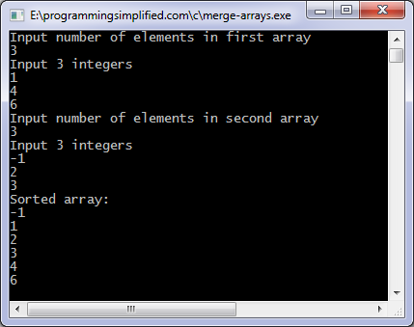

If the arrays are not sorted then you can sort them first and then use the merge function, another method is to merge them and then sort the array. Sorting two smaller arrays will take less time as compared to sorting a big array.

**Date: June 24, 2015**